**Experiment-7**

**Title:**

**Aim:**

**Pre-Requisite:**

1. XAMPP Installation (Windows/Linux Apache MySQL PHP Perl Stack)

[https://www.apachefriends.org/*download*.html](https://www.apachefriends.org/download.html)

1. Web Browser (Internet Explorer, Mozilla Firefox, Google Chrome etc.)

**Question 1:** Create a Simple Interest form in HTML and perform its calculation on server side using PHP

**HTML Code:**

<html>

<title>Calculator using HTML and PHP</title>

<form action="SimpleInterest.php" method="POST">

<center>

<table>

<tr><td>Principal Amount</td><td><input type="text" name="p"></td></tr>

<tr><td>Rate of Interest</td><td><input type="text" name="r"></td></tr>

<tr><td>Time</td><td><input type="text" name="t"></td></tr>

<tr><td><input type="submit" value="Calculate"></td><td></td></tr>

</table>

</center>

</form>

</html>

**Explanation:**

* **Form** is used to take input from user using name attribute which can be later processed using scripting languages like JavaScript, PHP etc.
* **Action** tag of form is used to define the path of the scripting file. If it is not specified, the browser searches for the scripting code in the same file.
* **Method** tag of form can take two values: **1) get** and **2) post**

Default method tag has value get but post is recommended for

* Secure data transactions
* Allows large amount of data flow without restrictions
* Blocks vulnerable functionalities
* Latest version of PHP does not follow the **align** CSS property and thus **center** tag is used here for alignment of the entire form.
* Input element is used to take **text** input for Principal, Rate of Interest and Time (in years) and also at end the Input element is used with a **submit** button for the action.

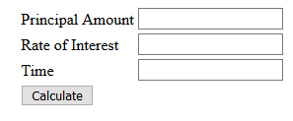

**PHP Code:**

<?php

$p=$_POST["p"];

$r=$_POST["r"];

$t=$_POST["t"];

$si=($p*$r*$t)/100;

echo "<h2> Simple Interest is = $si </h2>";

?>

**Explanation:**

* POST command is used to access HTML variable reference in PHP
* Echo command is used to return output to the HTML page

**Output:** HTML Page with P = 1000, R = 10 and T = 2

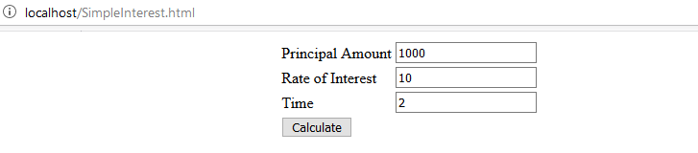

**Output:** PHP Page return HTML output after processing

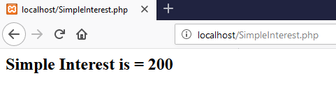

**Exercise 2:** Create a Compound Interest form in HTML and make a PHP code to process it.

**HTML Code:**

<html>

<title>Calculator using HTML and PHP</title>

<form action="CompoundInterest.php" method="POST">

<body style="background-color:lightblue;">

<h2 style="text-align:center;">Compound Interest Calculator</h2>

<center>

<table>

<tr><td>Principal Amount</td><td><input type="text" name="p"></td></tr>

<tr><td>Rate of Interest</td><td><input type="text" name="r"></td></tr>

<tr><td>Time</td><td><input type="text" name="t"></td></tr>

<tr><td>Frequency</td>

<td>

<select name="f">

<option value="half">Half Yearly</option>

<option value="year">Yearly</option>

</select>

</td>

</tr>

<tr><td><input type="submit" value="Calculate"></td><td></td></tr>

</table>

</center>

</form>

</html>

**Explanation:**

Here, we add on the SimpleInterest.html file with a new HTML element **select** for creating a dropdown menu having two values: Yearly and Half-yearly.

**Syntax:** Select Element

<select name=”{variable for scripting reference}”>

<option value=”Value to be compared in script”>HTML Display Option 1</option>

...

</select>

**Output:**

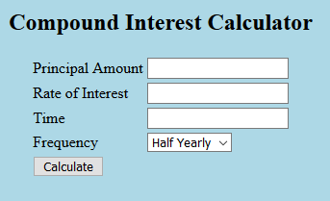

**PHP Code:**

<?php

$p=$_POST["p"];

$r=$_POST["r"];

$t=$_POST["t"];

$f=$_POST["f"];

$n=0;

if($f=="half")

{

$n=2;

}

if($f=="year")

{

$n=1;

}

$d=$n*100;

$a = $p*pow(1+$r/$d,$n*$t);

$ci=$a-$p;

echo "<h2> Compound Interest is = $ci </h2>";

?>

**Output:** HTML file (Half yearly calculation for P=1000, R=10 and T=2)

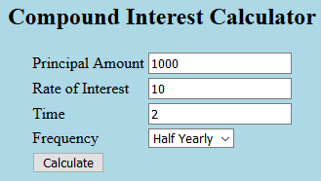

**Output:** PHP file

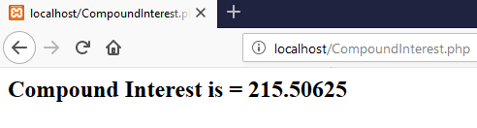

**Output:** HTML file (Yearly calculation)

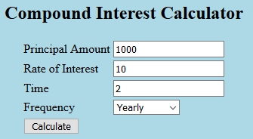

**Output:** PHP file

